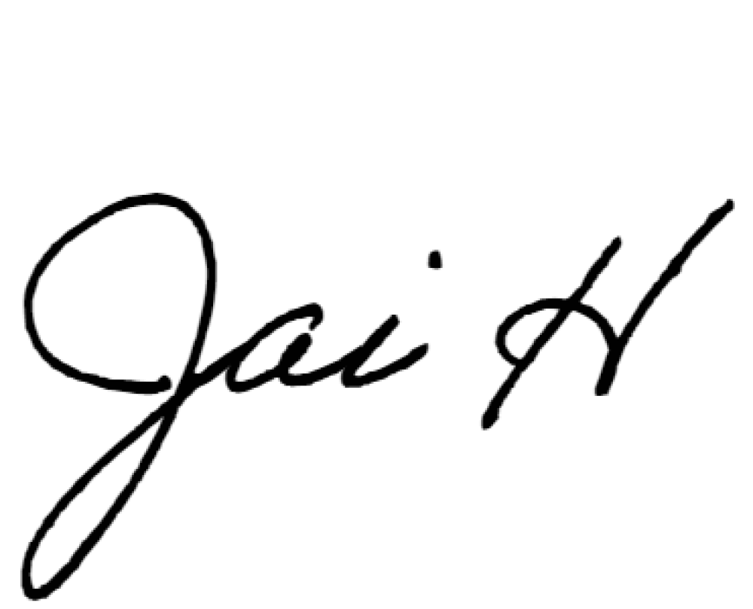


Date: {{date}}

PARTICIPATION LETTER
DeepFest 2026
Riyadh Exhibition & Convention Center (RECC), Kingdom of Saudi Arabia
31 August–3 September 2026

Dear Sir/Madam,

We hereby confirm that {{company_name}} company is exhibiting at the “DeepFest 2026” exhibition held from the 31th of August to the 3th of September 2026 at the Riyadh Exhibition and Convention Center (RECC). We appreciate your assistance in facilitating the visa issuing.

Participant Details
Name: {{name}}
Passport number: {{passport}}
Expiry Date: {{exp_date}}
Date of Arrival: {{date_arrival}}
Date of Departure: {{date_departure}}
The preparation of the exhibition will commence on August 18, 2026, and will end on the evening of September 4 , 2026.
This letter has been issued to the above-named exhibitor strictly for the purpose of supporting their visa application. Please note that the issuance of this letter does not guarantee the approval of a visa, which remains entirely at the discretion of the relevant embassy or consulate in the applicant’s home country.
Tahaluf bears no responsibility or liability if a visa is denied or delayed.

Should you have any queries regarding the event, please do not hesitate to contact the DeepFest customer service team DeepFestCS@Tahaluf.com .

Yours faithfully,

